**Accommodation rental values for property types in Lagos Island, Old Ikoyi and Southwest Ikoyi axis between 2019-2023**

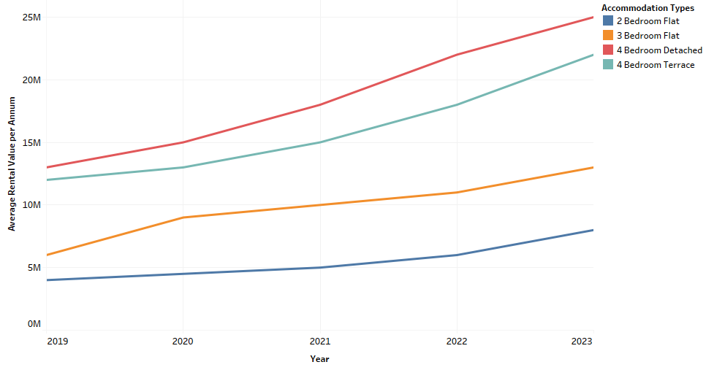

**Accommodation rental values for property types in Victoria Island and Oniru axis between 2019-2023**

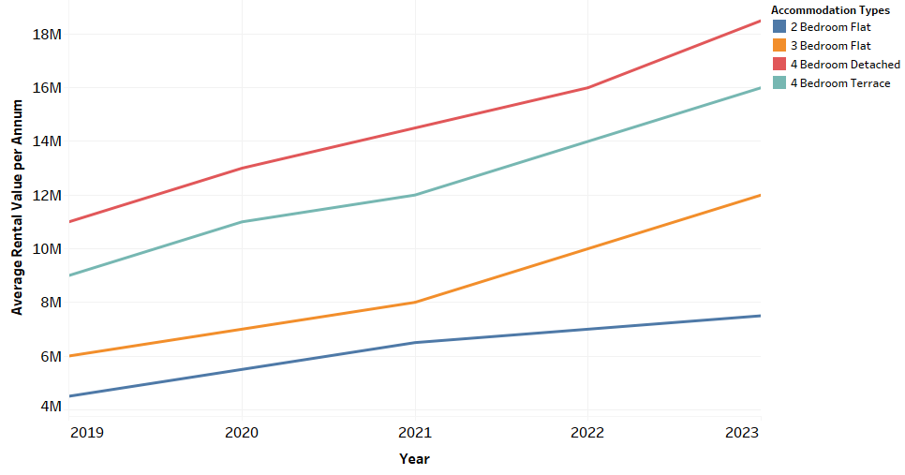

**Accommodation rental values for property types in Lekki Phase 1, Osapa and Chevron axis between 2019-2023**

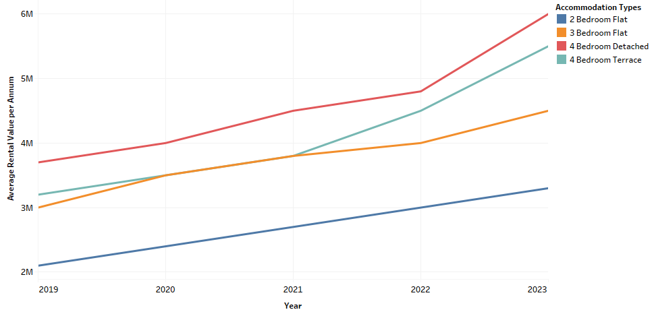

**Accommodation rental values for property types in Ajah, Sangotedo and Lakowe axis between 2019-2023**

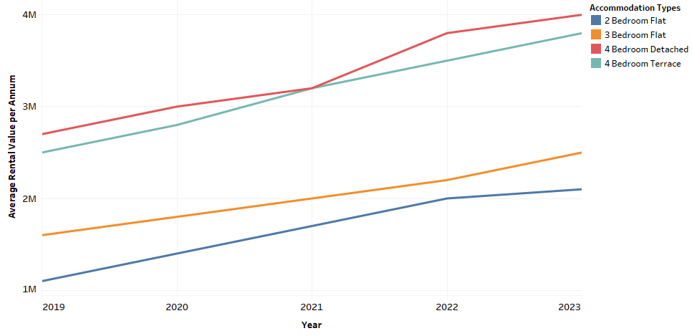

**Accommodation rental values for offices in Lagos Island axis between 2019-2023**

